Operation Active Resolve (OPAR) Introduction

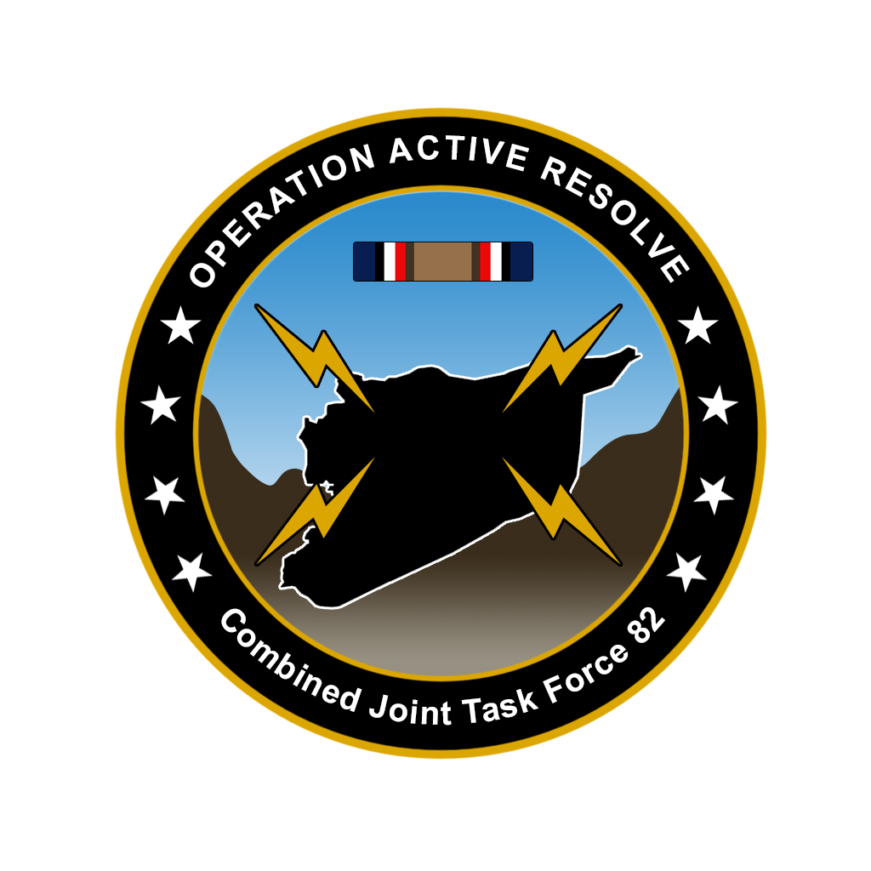

**Purpose:**

The purpose with this document is to provide everyone participating in OPAR with the necessary basic understanding of the construct of the campaign, the various roles taking part, and the various documents that can be encountered during the campaign. The purpose is furthermore to inform what is expected by all participants.

**Disclaimer:**

The functions and processes in the campaigns drawn from real world unclassified references but are simplified and adjusted to meet the need for conducting a 132nd Virtual Wing hosted campaign using DCS.

# Chapter 1: Introduction

Operation Active Resole (OPAR) is intended to be executed over a long period of time, and spanning over many events. The campaign will be executed with volunteers in the role of the Joint Force Air Combat Commander (leading the effort of planning and execution the air campaign) and Virtual Intelligence Service (supporting with intelligence analysis and assessment in support of the air campaign).

There is a lot of information, background intelligence and procedures to facilitate this. This is done to create all the necessary layers for both aircrew, controllers, and volunteers in the JFACC and VIS roles, but also for the mission designer so it will be possible to conduct events over a very long period of time with minimum of effort between each event.

Because of this, initially when starting the participation in the campaign, there is a lot of information to cover. It will take time to digest and get a good understanding of where all information is located and how it relates to each other and the events. This document is intended to aid in this process. Also, once a participant has attended a few events and know where information is located and get a good understanding of the various roles, the situation, the intelligence, and the process, it is much easier to participate and attend subsequent events. The immersive environment and the situation also make the participation in the campaign over time worth the time spent at the beginning getting into the campaign in a good way.

A full campaign that uses volunteers in the role of Joint Force Air Component Command (JFACC) and Virtual Intelligence Service (VIS) is very complex and consists of many various actors/roles and many various documents to support the campaign, the planning, and its execution.

# Roles/actors

## Player volunteer roles

Player volunteers can be 132nd members, but is also open for interested external participants that are interested in the full experience in running a air campaign or conducting intelligence work in support of the air campaign.

### Joint Force Air Component Command (JFACC) (Player volunteers)

Joint Force Air Component Command (JFACC) is the headquarter of the Joint Air Forces in the operation (Both Navy and Air Force, so for us in the OPAR campaign this means all air forces).

JFACC plans and executes air campaigns. JFACC have a role both in campaign planning for a campaign, but also for the planning for each ATO day (each event)

The JFACC role is about giving the direction and guidance for air operations. JFACC will publish its guidance before each ATO day in the Air Operations Directive (AOD), and this direction and guidance will be used by everyone involved, especially AWACS controllers and mission commanders/flight leads for planning packages or flights.

JFACC also holds responsibility as Airspace Controlling Authority (ACA) and Area Air Defense Commander (AADC) for OPAR, and will make sure to provide necessary instructions for keeping all aircrafts safe.

If needed JFACC may also request support from other component commands (Land, Sea and Special Operations).

### Virtual Intelligence Service (VIS) (Player volunteers)

The VIS role is about providing intelligence for the rest of the organization. The volunteers functioning in the role as VIS will try to make sense of the battlefield based on the reports from pilots after events, in addition to intelligence from VID (Virtual Intelligence Directive=Intelligence given from mission designer).

VIS has a dual purpose:

1. Support the event planning on a higher level (support to JFACC)
2. Support the event planning on a tactical execution level (support to pilots)

## Mission Designer

### Joint Force Commander (JFC) (Mission Designer)

JFC is the commander of a Joint Task Force or a Combined Joint Task Force. JFC will provide the overall guidance and mission to all components (land, sea, air, and special operations). In OPAR JFC is the commander of Combined Joint Task Force 82.

### Virtual Intelligence Directorate (VID) (Mission Designer)

VID provides intelligence injects into the campaign. This can be considered a broader intelligence agency than VIS. VID is the way the mission designer can inject relevant or irrelevant information into the campaign, that can be picked up by VIS and JFACC and used for the execution of subsequent events based on the new information.

### Land Component Command (LCC) (Mission Designer)

This is the land component of the Joint Force and controls the fight taking place on the ground. The land forces are slow to maneuver but are often the decisive factor. MCC and JFACC will often have a supporting role to help LCC reach their objectives.

### Maritime Component Command (MCC) (Mission Designer)

This is the maritime component of the Joint Force, consisting of surface ships, submarines. Naval aviation is for the 132nd purposes controlled by JFACC. Surface ships operating together may form a Surface Action Group (SAG) with mutual support. MCC may have several SAG`s. Maritime units are fewer in number than land units, and can easily be task organized in various SAG formations based on the need for the specific mission.

### Special Operations Component Command (SOCC) (Mission Designer)

This is the special operations component of the Joint Task Force. Special operations can be used for sensitive missions, or demanding missions that LCC is not suited for. Typical insertions deep behind the enemy line to provide intelligence, or to support attacks by JTACs.

# Products

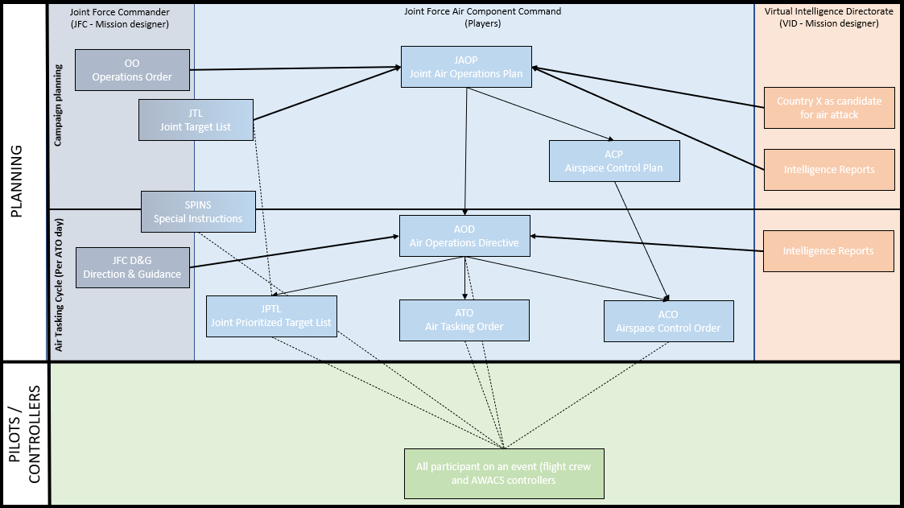

Figure 1 Campaign products

## Air Campaign Planning Products:

Air campaign planning products are provided or created prior to the first event in a campaign:

### Operation Order (Created by mission designer)

The operation order is the overall order from the Joint Force Commander (JFC). It will contain an overall situation, an overview of friendly and enemy forces. It will also contain the mission and the commander’s intent with the operation. Furthermore, the operation order contains a broad concept of operation and objectives to be met. The operation order will also list specific tasks to the component commands (Land, Air, Sea, Special operations).

Target audience for the operation order is **JFACC and VIS**.

### Syria as Candidate for Air Attack (Created by mission designer)

The candidate for air attack study is provided by the mission designer to VIS and JFACC to be used in planning and execution of the campaign. The attack study contains a lot of information about the enemy’s system for use in targeting and development of additional intelligence.

Target audience for Syria as Candidate for Air Attack Study is **VIS and JFACC**.

### Joint Target List (JTL) (Created by mission designer)

The Joint Target List is a master list of available targets to be attacked during the air campaign. The effects of attacking the various targets vary, but all targets on the Joint Target List is targets that may influence the progress in the campaign. The Joint Target List is created by VID and provided to VIS/JFACC when VIS/JFACC starts planning the air campaign.

Target audience for the JTL is **VIS and JFACC**.

### Special Instructions (SPINS) (Created by mission designer and JFACC)

This is a document used for mission designer and JFACC to provide important information for the campaign and its execution. SPINS are to be read by all pilots and controllers participating on an event.

Target audience for the SPINS is **Everyone** involved in the campaign.

### Joint Air Operations Plan (JAOP) (Created by JFACC)

The JAOP is JFACC`s overall plan on how to conduct the campaign. The JAOP will have the mission for JFACC together with JFACC’s intent and the objectives for JFACC. It will contain the concept of operation through information of what is planned to be conducted during the various phases in the operations. The phases may be given in the Operations Order, but JFACC can add new phases or break down the phases in various sub phases. The JAOP will also include a timeline over the various phases and sub phases. The JAOP is created prior to the first event and will be the guiding document for further events.

Target audience for the JAOP is **Mission designer** + **aircrew, JTACs and controllers** (to get the big picture)

### Airspace Control Plan (ACP) (Created by JFACC)

As part of the air campaign planning, JFACC with its responsibility as Airspace Control Authority (ACA) create an Airspace Control Plan that contain all necessary regulations for the use of the airspace during the campaign. The ACP includes transit corridors, routes, navigation points, contact points, initial points, kill boxes, minimum risk routes, fighter areas of responsibility, missile engagement zones. Points/areas in the ACP are used as basis for the creation of the Airspace Control Order (ACO) that supports each Air Tasking Order (ATO).

Target audience for the ACP is **Mission designer + JFACC during execution**.

## Air Tasking Cycle Products:

Air tasking cycle products are provided or created for each ATO day or event in a campaign:

### Joint Force Commander Direction & Guidance (JFC D&G) (Created by mission designer)

When necessary (before an ATO day or a new phase), JFC may see it necessary to provide additional direction and guidance for the overall campaign. This will be published in the JFC D&G document.

Target audience for the JFC D&G is **JFACC and VIS**.

### Air Operations Directive (AOD) (Created by JFACC)

During the execution of the air campaign JFACC uses the AOD to guide and influence operations and taskings. The AOD is JFACC’s broad plan and guidance for the execution of an ATO day or phase. The AOD is an important document as it contains the necessary directions and guidance for AWACS controllers to act in accordance with JFACC intent.

Target audience for the AOD is **Mission designer, AWACS controllers, JFACC** (for breaking it down into the ATO) **and all aircrew flying on that ATO day** to get the situational awareness of the situation for that ATO day or that phase.

### Air Tasking Order (ATO) (Created by JFACC)

During the execution of the air campaign, the ATO is used daily by JFACC to give detailed taskings to flights and squadrons. The ATO gives information about the mission for each flight that are to be flown that ATO day.

Target audience for the ATO is **Mission designer,** **Aircrew, JTACs and controllers** that are participating on the event for that ATO.

### Airspace Control Order (ACO) (Created by JFACC)

The ATO is supported by the ACO which provide the detailed information regarding the planned use of the airspace for the specific ATO day. The ACO activates already planned points/areas on the Airspace Control Plan (ACP).

Target audience for the ACO is **AWACS controllers, JTACs and aircrew** (for flight planning and preparation)

### Joint Prioritized Target List (JPTL) (Created by JFACC)

The Joint Prioritized Target List (JPTL) is a list of planned targets to be attacked for a specific ATO day. JPTL are added as an annex to the AOD.

Target audience for the JPTL is **AWACS controllers, JTACs + aircrew flying that** event to get a better situational awareness.

## Other products

In addition to the products mentioned in the previous section, other products may also be encountered during a campaign:

### Intelligence reports (Created by mission designer or VIS)

VID and VIS (if participating in the campaign) will publish intelligence reports which gives updates to the enemy situation. This is something JFACC need to bring into its planning and decide if they need to change their plans or change their priorities.

### Concept of operations (CONOP) (Created by mission designer or JFACC)

From time to time the other components (Ground, Sea, SOF) may provide a concept of their operations. This is provided so JFACC gets a better understanding of the other friendly operations planned. JFACC can then better figure out they can support the other components. A Concept of operation can also be provided by JFACC for approval by JFC for a specific sensitive operation as ordered by Joint Force Commander (JFC).

# General concepts

When using JFACC and VIS construct in 132nd hosted campaign the following guiding principles are effective:

* One ATO Day is divided into several events.
  + This is decided between mission designer and JFACC/VIS volunteers
  + Typically, one ATO day consist of minimum 2 events
  + The benefit this gives is that the products created for an event is still valid also for the next event and thus, events can be conducted at a more rapid pace. The only artificiality is that for event number two, JFACC will need to create a new ATO to facilitate for the signups on the actual date. But other products such as AOD, JPTL, ACO is still valid with the same information. For each ATO day JFACC/  
    VIS will be informed prior to planning that ATO day how many events the ATO day is divided into, and what time windows the events will cover (day and/or night).
* ATO day in a campaign is given the name D1 (for first day of campaign), D2 (second day), etc.
  + If more events are conducted on the same ATO day, then the event number for the day is added:
    - ATO Day 1, event 1: D1.1
    - ATO Day 1, event 2: D1.2
    - ATO Day 2, event 3: D2.3

# Expectations

In order to be able to simulate a air war to the most immersive experience possible in DCS it requires a lot for everyone involved. For participants attending OPAR the following is expected:

* Come prepared to the campaign and each event (read all required background materials such as intelligence reports and this document).
* Be dedicated: When signing up for a combat event, be aware that you will need some time to plan and prepare for the event. Combat events are conducted Sundays, and taskings are typically published Friday evening at the latest.
* Be committed: When committed (signed up), not sign up if not sure if you can attend or not. Everyone can and will have real life emergencies that show up that may preclude someone from attending at times, but try to keep this to a minimum as fallout of individuals can have a impact on other players experience.
* Sign up on time, follow the instructions given in event info as this will make it easier for mission maker and JFACC
* Be available for flight lead and mission commander duties if assigned to these roles.

# Where to find information

* 132nd Website:
  + Event info
  + ATO
  + AAR
* Website briefing:
  + Intelligence
  + Orders
  + SPINS
  + Admin
  + Weather forecast
* Discord OPAR section: (OPAR tag given to participants for access, both 132nd and externals upon reading the admin documents and notifying mission designer)
  + **JFACC:** JFACC internal channel for work related to JFACC processes.
  + **VIS:** VIS internal channel for work related to VIS processes.
  + **JFACC-VIS:** Internal coordination channel between JFACC and VIS. Only for VIS and JFACC.
  + **RFI:** Channel for everyone to submit request for information
  + **Products:** Channel for everyone where CJTF HQ, JFACC, VIS or VID publish information (will also be made available on the OPAR briefing page)
  + **Media**: Channel for everyone where media reports may appear.
  + **BDA/Reports:** Channel for everyone where pilots report imagery and screenshots or other relevant information that is not published in the AAR from events
  + **Event planning:** Channel for everyone where information for the next event can be coordinated and discussed.
  + **OPAR coordination:** Chanel for everyone where coordination can be done. Anything not suited for other discord channels